BSc in Software Development

Year 3

COMP07030 Software Design Project

*<2D Wave Game>*

*<G00263842>*

*<David Needham>*

Contents

Introduction 3

Architecture of the solution 3

Class diagram and Data Model 3

Technologies used 3

Problems Encountered/Solved 4

Conclusions 4

Student Number: G00263842

Student Name: David Needham

Supervisor: Brian McGinley

GitHub Link<: https://github.com/DaveNAchill/Game>

# Introduction

*I have a huge interest in gaming[1]. I have always wanted[2] to develop a game in Unity but never had the opportunity until this year. I followed a few tutorials to get the feel for Unity. I then decided to develop a 2D Wave survival game. I think that 2D games were fun and easy to understand so I decided to try and design one myself. Even though the 2D game concept is old it is still a very popular type of game to play. There are many 2D games on mobile and websites like Facebook and have proven very popular.* The basic “hop and bop” formula of 2D platform games seems to work. Video game designers are creating more 2D platformers at an increasing rate, and people are buying them. 2D platformers offer simplicity and challenging game play that aren’t overshadowed by useless special effects.

The game I designed is a wave survival game where you play as a spaceman who has to survive a wave of enemy UFO’s. You are equipped with a gun to shoot them. If a enemy Ufo hits the player you lose a small bit of health. The controls are the just basic arrow keys on a keyboard to move left, right, up and down. Hit spacebar to jump and hold the left mouse button to shoot the weapon.

# Architecture of the solution

*The overall design for the project was made using software called Unity. I decided to use Unity as it has a really user friendly interface and has a large community with lots of resources online. Before I decided on using Unity i looked at designing a game for Android. After some time using Android Studio I found that without extensive knowledge of Android programming, It would have be difficult to design a game on Android.*

# Class diagram and Data Model

**Project Structure**

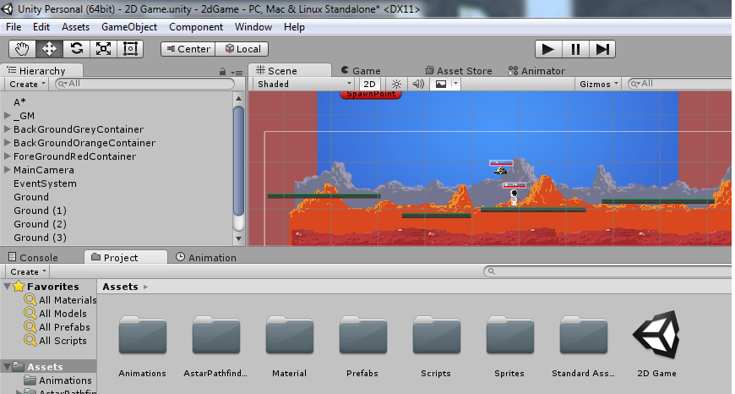

**2D view of the game**

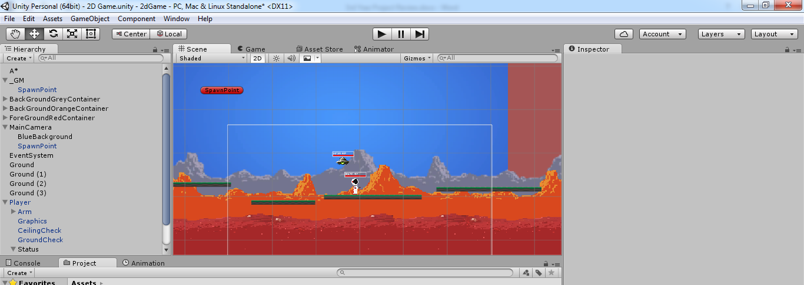

**3D view of the game showing each layer when the game is rendered.**

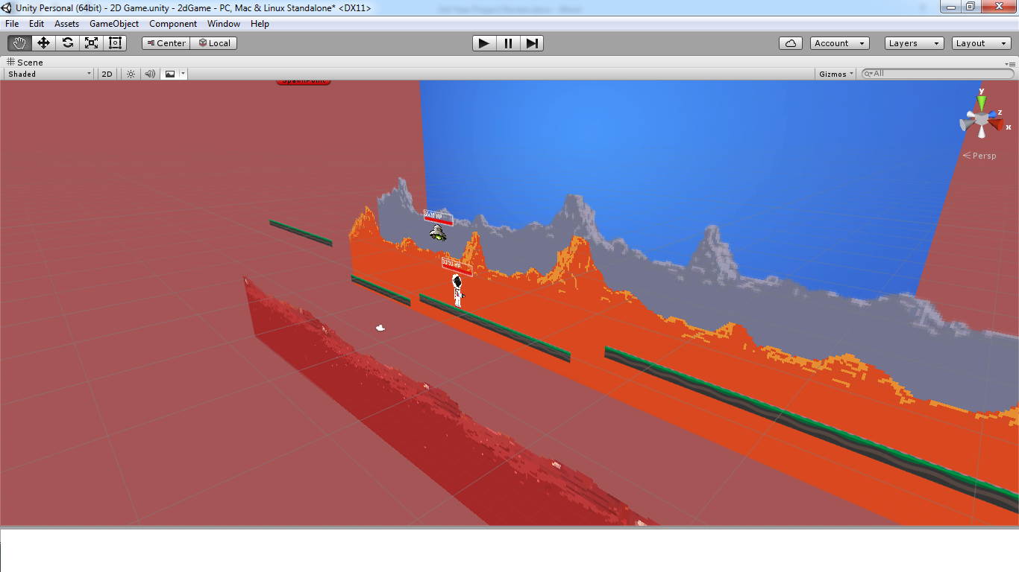

**Animation Overview**

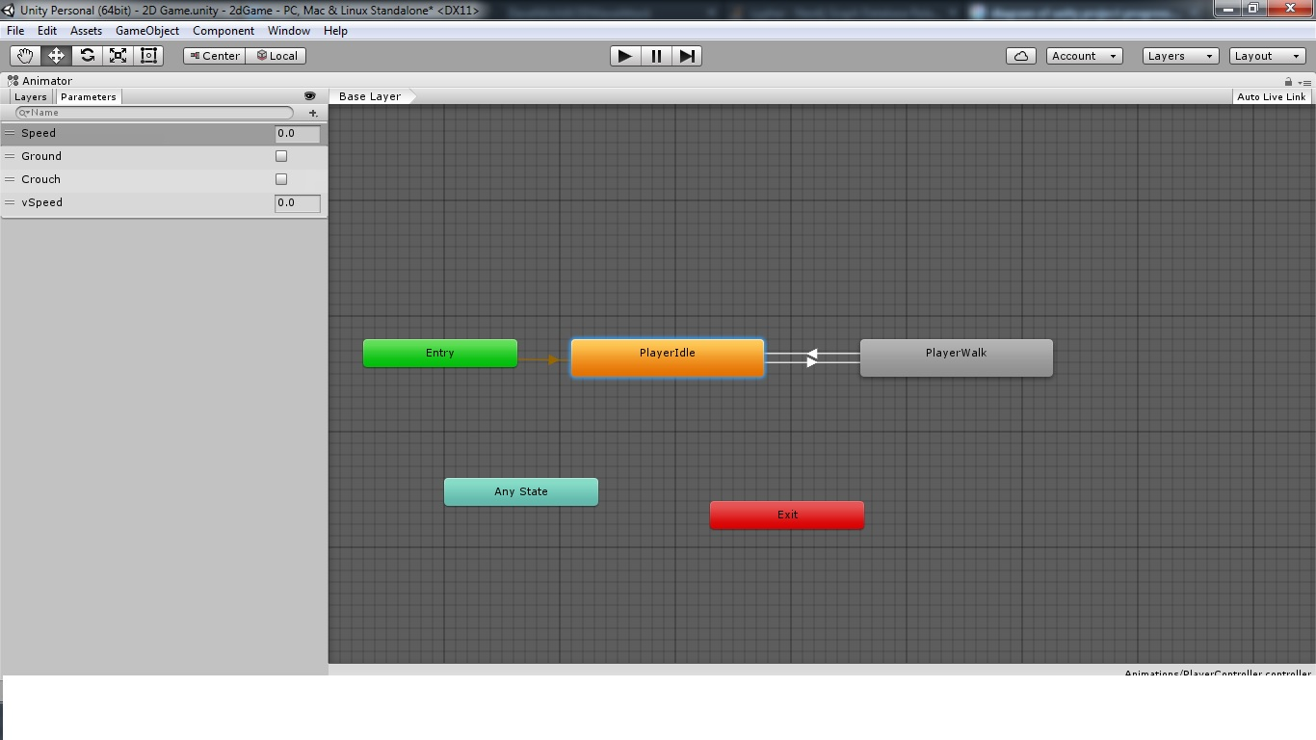

**Project Structure:**

*This is the overview of a Unity project. It includes all the assets used in the game. Assets include:*

***Animations:*** *Used to make the sprites move or walk.*

***Materials:***Rendering components used in Unity. They play an essential part in defining how your object is displayed.

**Prefabs:** Is a type of asset and a reusable GameObject stored in Project View. Prefabs can be inserted into any number of scenes, multiple times per scene.

**Scripts:** Unity allows you to create your own Components using scripts. These allow you to trigger game events, modify Component properties over time and respond to user input in any way you like.

**Sprites:** The Sprite is a Texture Type for use with the 2D framework

**3D view of the game:**

*What you see in the 3D view of the game is the different sorting layers of the game.* Sorting Layers and Order in Layer are used by the Sprite Renderer to determine the render order of sprites in a scene. Layers are most commonly used by Cameras to render only a part of the scene, and by Lights to illuminate only parts of the scene. But they can also be used by raycasting to selectively ignore colliders or to create collisions.

**Enemy AI:**

For the enemy AI I used a script called A*Pathfinding which is a free script available online. This allows the enemy to know where the player is and go towards the player. It can detect obstacles to avoid. (A*Pathfinging, n.d.)

# Technologies used

*I designed the game using the game Engine called Unity. It is a cross-platform game engine used to make games. Platforms include consoles, PC, flash games and mobile devices. The engine targets the following APIs: Direct3D on Windows and Xbox 360, OpenGL on Mac and Windows, OpenGL ES on Android and iOS; and proprietary APIs on consoles. Unity allows specification of texture compression and resolution settings for each platform the game engine supports.* Unity is versatile for its ability to create video games for multiple platforms. Within a project, developers have control over delivery to mobile devices, flash games, desktops, and video game consoles.

The main programming language used in unity is C Sharp. C sharp was developed by Microsoft within its .NET initiative. C# is one of the programming languages designed for the Common Language infrastructure. The C# language is intended to be a simple, modern, general-purpose, object-oriented programming language. The language is intended for use in developing software components suitable for deployment in distributed environments. I was pleasantly surprised to find that Unity used C Sharp to develop games as I had a lot of previous experience using C Sharp from using Visual Studio. This game me the confidence to attempt this project.

# Problems Encountered/Solved

*Some problems I encountered when deciding on what project to design was deciding on to design a game on Android Studio or some other software. After some research I decided on Unity. One problem I had was designing a game with Android studio. After some attempts at using it I decided that I had no previous experience with Android. After some research online I discovered Unity. It uses C Sharp to program its games and I had done some C Sharp before.*

*With the game itself I had some problems with:*

* *Re-spawning the player when he falls off the platform*
* *Problem with his arm rotation when moving*
* *When enemies collide with a platform they stop*

# Conclusions

*From a person who really enjoys games in general, the overall experience has been very interesting for me. At first I thought the task of designing and making a game would be very challenging but after some research online I found the overall process to be very doable. The Unity software is very well designed and fairly easy to use for the average user. It makes the whole process of designing a game a lot easier than by other means. At first I thought of designing the game on the Android platform but after a few attempts I found the task to be quite difficult. The 2D game I designed was simple but easy to play and understand. I feel the game could be further developed to make a better game with not too much difficulty.*

*After doing this project I would be interested in going into further game development in the future after I finish this course. Hopefully with the experience and skills I have learned from doing Software Development it will allow me to go into some form of game development.*

# References

**2D Tutorial for layers sprites and player physics**

<https://unity3d.com/learn/tutorials/topics/2d-game-creation>

**AI Script**

<http://arongranberg.com/astar/>

**Background Parallaxing (Background continues forever)**

<https://www.youtube.com/watch?v=DIQFhEo1C8c>

1. **AI Script:** <http://arongranberg.com/astar/>
2. www.google.com